**CHAPTER 12**

**PCB DESIGNING**

**12.1 PRINTED CIRCUIT BOARD (PCB)**

A printed circuit board (PCB) mechanically supports and electrically connects [electronic components](http://en.wikipedia.org/wiki/Electronic_component) using [conductive](http://en.wikipedia.org/wiki/Electrical_conductor) tracks, pads and other features [etched](http://en.wikipedia.org/wiki/Industrial_etching) from copper sheets [laminated](http://en.wikipedia.org/wiki/Laminated) onto a non-conductive [substrate](http://en.wikipedia.org/wiki/Substrate_(electronics)). PCBs can be single sided (one copper layer), double sided (two copper layers) or multi-layer. Conductors on different layers are connected with plated-through holes called [vias](http://en.wikipedia.org/wiki/Via_(electronics)" \o "Via (electronics)). Advanced PCBs may contain components - capacitors, resistors or active devices - embedded in the substrate.

Printed circuit boards are used in all but the simplest electronic products. Alternatives to PCBs include [wire wrap](http://en.wikipedia.org/wiki/Wire_wrap) and [point-to-point construction](http://en.wikipedia.org/wiki/Point-to-point_construction). PCBs require the additional design effort to lay out the circuit but manufacturing and assembly can be automated. Manufacturing circuits with PCBs is cheaper and faster than with other wiring methods as component are mounted and wired with one single part. Furthermore, operator wiring errors are eliminated.

When the board has only copper connections and no embedded components it is more correctly called a printed wiring board (PWB) or etched wiring board. Although more accurate, the term printed wiring board has fallen into disuse. A PCB populated with electronic components is called a printed circuit assembly (PCA), printed circuit board assembly or PCB assembly (PCBA). The IPC preferred term for assembled boards is circuit card assembly (CCA),[[1]](http://en.wikipedia.org/wiki/Printed_circuit_board" \l "cite_note-1) for assembled [backplanes](http://en.wikipedia.org/wiki/Backplane) it is backplane assemblies. The term PCB is used informally both for bare and assembled boards

Printed circuit board artwork generation was initially a fully manual process done on clear Mylar sheets at a scale of usually 2 or 4 times the desired size. The schematic diagram was first converted into a layout of components pin pads, then traces were routed to provide the required interconnections. Pre-printed non-reproducing Mylar grids assisted in layout, and rub-on [dry transfers](http://en.wikipedia.org/wiki/Dry_transfer) of common arrangements of circuit elements (pads, contact fingers, integrated circuit profiles, and so on) helped standardize the layout. Traces between devices were made with self-adhesive tape. The finished layout "artwork" was then photographically reproduced on the resist layers of the blank coated copper-clad boards.

Modern practice is less labour-intensive since computers can automatically perform many of the layout steps. The general progression for a commercial printed circuit board design would include:

* [Schematic capture](http://en.wikipedia.org/wiki/Schematic_capture) through an [electronic design automation](http://en.wikipedia.org/wiki/Electronic_design_automation) tool.
* Card dimensions and template are decided based on required circuitry and case of the PCB. Determine the fixed components and [heat sinks](http://en.wikipedia.org/wiki/Heat_sink) if required.
* Deciding stack layers of the PCB. 1 to 12 layers or more depending on design complexity. [Ground plane](http://en.wikipedia.org/wiki/Ground_plane) and [power plane](http://en.wikipedia.org/wiki/Power_plane) are decided. Signal planes where signals are routed are in top layer as well as internal layers.
* [Line impedance](http://en.wikipedia.org/wiki/Line_impedance) determination using dielectric layer thickness, routing copper thickness and trace-width. Trace separation also taken into account in case of differential signals. [Micro strip](http://en.wikipedia.org/wiki/Microstrip), [strip line](http://en.wikipedia.org/wiki/Stripline) or dual strip line can be used to route signals.
* Placement of the components. Thermal considerations and geometry are taken into account. [Vias](http://en.wikipedia.org/wiki/Via_(electronics)) and lands are marked.
* Routing the [signal traces](http://en.wikipedia.org/wiki/Signal_trace). For optimal [EMI](http://en.wikipedia.org/wiki/Electromagnetic_interference) performance high frequency signals are routed in internal layers between power or ground planes as [power planes](http://en.wikipedia.org/wiki/Power_plane) behave as ground for AC.

**12.2 PCB DESIGNING**

It consists of two steps:

• To prepare schematic in any of PCB design software, such as Circuit Wizard, Orcad, Diptrace, Escad, Smart PCB, Proteus 8 etc. We made our schematic in Circuit Wizard.

• The second step is to prepare PCB layout either by auto routing or manual routing.

We used manual routing.

**12.3 PCB PREPARATION TECHNIQUES**

**12.3.1 SOFTWARE APPROACH:**

[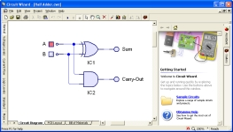](http://www.electronics-micros.com/img/cwizard/screenshot1.jpg)The first step to design a PCB is to prepare an artwork of the circuit using PCB software. Various softwares like ORCAD, PCB Wizard etc. are available for

this purpose. Here we have adopted Circuit Wizard is an electronic design program produced by [New Wave Concepts](http://www.new-wave-concepts.com/) which offers a range of features likely to be of particular appeal to electronics hobbyists and educational users, including schematic capture, interactive simulation and PCB design.

[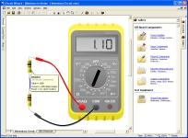](http://www.electronics-micros.com/img/cwizard/screenshot2.jpg)Circuit diagrams may be rapidly created and simulated, with animated components and virtual test instruments allowing the user to interact with the circuit in real-time.

[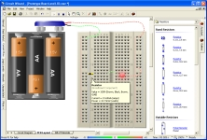](http://www.electronics-micros.com/img/cwizard/screenshot3.jpg)Available circuit types include elementary circuits (real world component view with manually connected wires, as seen above), schematic drawings using standard electronic symbols (top image), and even prototype board layouts, as seen below.

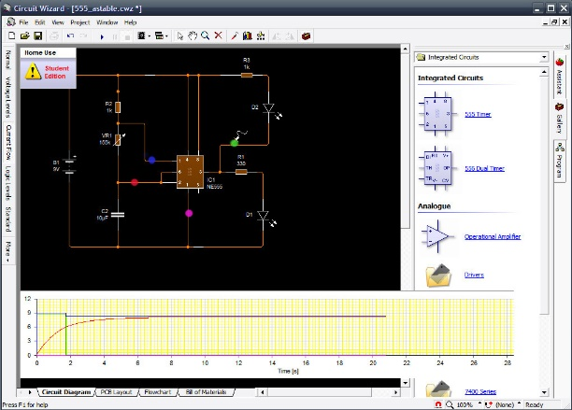[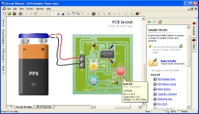](http://www.electronics-micros.com/img/cwizard/screenshot4.jpg)The design may then be converted to a PCB, using either manual or automated routing, or the PCB based circuit may be simulated as a final check prior to manufacture. (PCBs use through-hole components rather than surface mount, making them suitable for manufacture by hobbyist and educational users.)

After designing the layout, the software provides us the real world view, art work etc. We need to take a print out of the mirror image of the artwork on a glazing paper. This mirror image printout is used for screen printing.

**12.3.2 ETCHING**

Etching [your own circuit boards](https://mad-science.wonderhowto.com/how-to/diy-lab-equipment-etch-your-own-circuit-boards-using-laser-printer-0134931/) is tons of fun, but etching requires [strong chemicals](https://mad-science.wonderhowto.com/how-to/diy-lab-equipment-make-etch-tank-for-rapid-pcb-fabrication-0134963/) to dissolve the copper plating on blank circuit boards. The normal ferric chloride solution works well, but can be expensive and leaves permanent stains. Luckily, we can whip up our own etchant at home with everyday chemicals! Better yet, our new etchant will turn an eerie green color rather than the dull brown of ferric chloride.

Materials

* Muriatic Acid (diluted HCl)
* Hydrogen Peroxide

**Step 1 Get Chemicals**

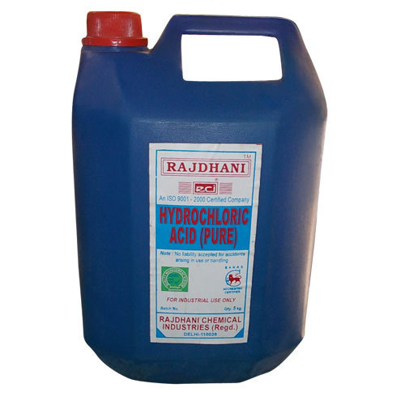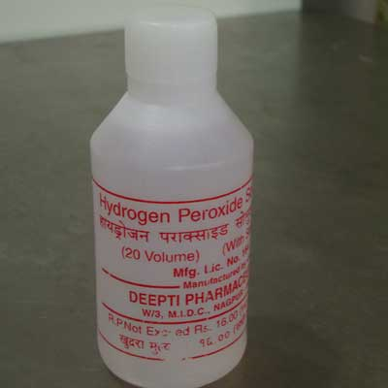**Hydrogen peroxide** is available at any drug store. It usually comes in a 3% solution for medical purposes. This will be fine for etching. If you have a higher concentration of hydrogen peroxide, be sure to dilute it to 3% before mixing anything.

**Warnings**

* Do not touch, breath, or ingest hydrochloric acid!
* Use respiratory protection when opening the bottle of acid.

**Step 2 Mixing**

Mix two-parts of diluted hydrogen peroxide with one-part muriatic acid. There you are, done!

The hydrogen peroxide acts as an oxidizer allowing the acid to eat away the copper. Place your board to be etched in your new solution and watch it go! Your board will etch suspiciously fast, but don't worry, that's what is supposed to happen!

After the first etch, you should notice the solution starting to acquire a light green tint. This is the copper that has dissolved into the solution. This green color will grow deeper with each use. The dissolved copper creates cupric chloride which can itself be used to etch metal.

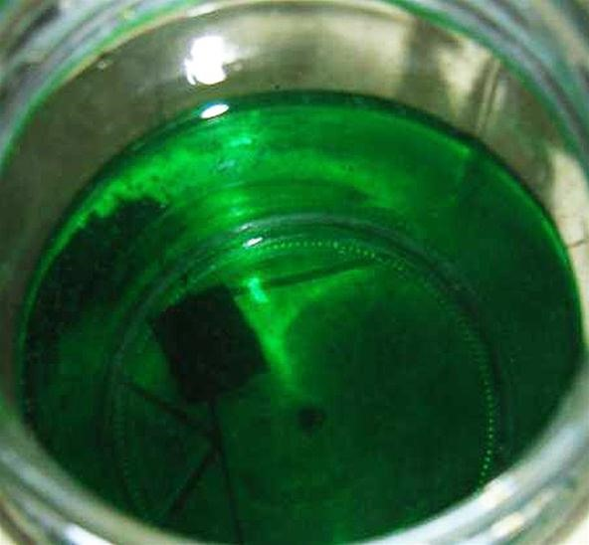

Keeping the ratio of hydrogen peroxide to hydrochloric acid is rather difficult over the course of multiple etchings. Both solutions contain water and the etching reaction itself produces water. As I am no chemist, reproduced below is some chemical information concerning cupric chloride etching.

**Hydrogen Peroxide As a Replenisher**

"The Hydrogen Peroxide (H2O2) system of replenishing has been popular in the Photochemical Milling industry. Using this system requires a reliable control system, for both components required to replenish the system, Hydrogen Peroxide, and Hydrochloric Acid.

The use of Hydrogen Peroxide also produces a purer Cupric Chloride, without Sodium Chloride (NaCl) impurities, but the Hydrochloric Acid level must be carefully monitored, as it is consumed in the regeneration part of the reaction. This replenishment method also suffers from the fact that over-replenishing with the Hydrogen Peroxide can generate free Chlorine gas."

Follow [this link](http://rdchem.com/chemistry-of-the-cupric-chloride-etch.html) for more information.

If you want to get the maximum amount of copper into your cupric chloride solution, check out this awesome [tutorial](http://www.instructables.com/id/PCB-Etching-Solution-Cupric-Chloride/).

Warnings

* If you didn't catch that, messing up this solution can cause the release of chlorine gas which is a chemical weapon and quite nasty. Do not mess with adding lots of hydrogen peroxide to your solution unless you have a reliable way of measuring the solution contents. Always perform dangerous chemistry outside or under a fume hood.
* As a side not, melting PVC can also release chlorine gas. Do not laser etch your moleskin notebooks!

Hydrogen peroxide is unstable and breaks down very quickly when exposed to light (hence the opaque brown bottle at the pharmacy). Store the etchant solution in an airtight opaque container to maintain the ratio of chemicals. If exposed to light, the ratios will be out of balance and your etchant will work at a snail's pace.

**12.3.3 DRILLING**

After etching the PCB the next step is to drill the required holes at required places on the board. If you have fibre glass (FR4) board, you must use tungsten carbide drill bits. Fibre glass eats normal high-speed steel (HSS) bits very rapidly, although HSS drills are all right for odd larger sizes (>2 mm). Carbide drill bits are expensive and the thin ones snap very easily. When using carbide drill bits below 1 mm, you must use a good vertical drill stand- you will break drill very quickly without one. Carbide drill bits are available as straight-shank or thick (sometimes called ‘turbo’) shank. In straight shank, the whole bit is the diameter of the hole, and in thick shank, a standard-size (typically about 3.5 mm) shank tapes down to the hole size. The straight-shank drills are usually preferred because they break less easily and are usually cheaper. The longer thin section provides more flexibility.

Small drills for PCB use usually come with either a set of collets of various sizes or a 3-jaw chuck. Sometimes the 3-jaw chuck is an optional extra and is worth getting for the time it saves on changing collets. For accuracy, however, 3-jaw chucks aren’t brilliant and small drill sizes below 1 mm quietly from grooves in the jaws, preventing good grip. Below 1 mm, you should use collets, and buy a few extra of the smallest ones, keeping one collets per drill size, as using a larger drill in a collets will open it out and it no longer grips smaller drills well. Avoid hole-sizes less than 0.8 mm unless you really need them. When making two identical boards, drill them together to save time. To do this, carefully drill a 0.8 mm hole in the pad near each corner of each of the two boards, getting the centre drill a 0.8 mm hole in the pad near each corner of each of the two boards, getting the centre as accurate as possible. For larger boards, drill a hole near the centre of each side as well. Lay the boards on top of each other and insert a 0.8mm track pin in two opposite corners, using the pins as pegs to line the PCBs up. Squeeze or hammer the pins into the boards, and then into the remaining holes. The two PCBs are now ‘nailed’ together accurately and can be drilled together.

**12.3.4 SOLDERING**

After drilling next important step involved is the soldering of various components like IC, resistors, capacitors etc. Since the tracks drawn on the board are mirror images proper care must be taken to place the right component at the right place. The real world view provided by the PCB Wizard software must be used as an aid for this purpose.

Soldering is the joining together of two metals to give physical bonding and good electrical conductivity. It is used primarily in electrical and electronic circuitry. Solder is a combination of metals, which are solid at normal room temperatures and become liquid at between 180 and 200ºC. Solder bonds well to various metals and extremely well to copper.

To solder you need a soldering iron. A modern basic electrical soldering iron consists of a heating element, a soldering bit (often called the tip), a handle and a power cord. The heating element can be either a resistance wire wound around a ceramic tube, or a thick film resistance element printed onto a ceramic base. The

element is then insulated from the handle. The heating element of soldering iron usually reaches temperatures of around 370 to 400ºC (higher than that needed to melt the solder). The soldering bit is a specially shaped piece of copper plated with iron and usually plated with chrome or iron. The tip planting makes it a very resistant to aggressive solders and fluxes. The strength or power of a soldering iron is usually expressed in watts. Irons generally used in electronics are typically in the range 12-25 watts. Higher powered iron will not run hotter, but it will have more power available to quickly replace heat drained from the iron during soldering. Most irons are available in a variety of voltages; 12V, 24V, 115V and 230V are the most popular. Today most laboratories and repair shops use soldering irons which operate at 24V (powered by isolation transformer supplied with the soldering iron or by a separate low voltage outlet). You should always use this low voltage where possible, as it is much safer.

You need to be careful in soldering because most electronic components are fragile and heat sensitive. Usually our biggest concern is heat. Low enough soldering temperature and short enough soldering time keeps components in good shape. Electronics components are designed that they can take high temperatures on their contacts/wires for some time without damages (to withstand the soldering). Prolonged exposure to high temperature will heat up when inside of the component can cause damage to it. Currently, the best component available, workable and safe solder alloy is 63/37. That is 63% lead, 37% tin. It is also known as eutectic solder. It is most desirable characteristic is that it solids (“pasty”) state, and its liquid state occur at the same temperature – 361 degrees F. The combination of 63% lead and 37% tin melts at the lowest possible temperature.

The metals involved are not the only things to consider in a solder. Flux is vital to a good solder joint. Flux is an aggressive chemical that removes oxides and impurities from the parts to be soldered. The chemical reactions at the points of connection must take place for the metals to fuse. RMA-type flux (Rosin Mildly Active) is the least corrosive of the readily available materials, and provides an adequate oxide removal.

There are certain safety measures which you should keep in mind when soldering. The tin material used in soldering contains dangerous substances like lead (40-60% of typical soldering tins are lead and lead is poisonous). While it is true that lead is not vaporized at the temperatures at which soldering is typically done, particulate matter is just as dangerous as fumes would be in terms of poisoning and there is particulate lead present to some extent in the fumes from your flux.